Website Address: <http://flights.ctrip.com/>

The Ctrip platform is called 携程 in Chinese. It is a platform that aims at helping you with your journey. Most people use it to book plane tickets and hotel rooms. Since it is well-known for its plane ticket service, I decided to go through the process of booking a plane ticket.

1. The interface really offended the principle of Minimalism.

The information that pops out aren’t really important. Most users will have to look carefully to see what they are looking for (e.g. schedule for a specific flight, etc.). What they could see at the first glance are only the ads.

Severity Rating: 2





1. I am not satisfied with the Freedom aspect of the interface. There are something to improve about it.

Below is the interface where I could select possible flights and send my order. (Ctrip is a platform that would book tickets for you, thus you don’t have to deal with the official websites of different companies).

Users could only choose one way to sort the result of searching. By time, price, probability of being on time, or all mixed together.

I think it won’t be hard to apply multiple attributes to sort at once.

Severity Rating: 1

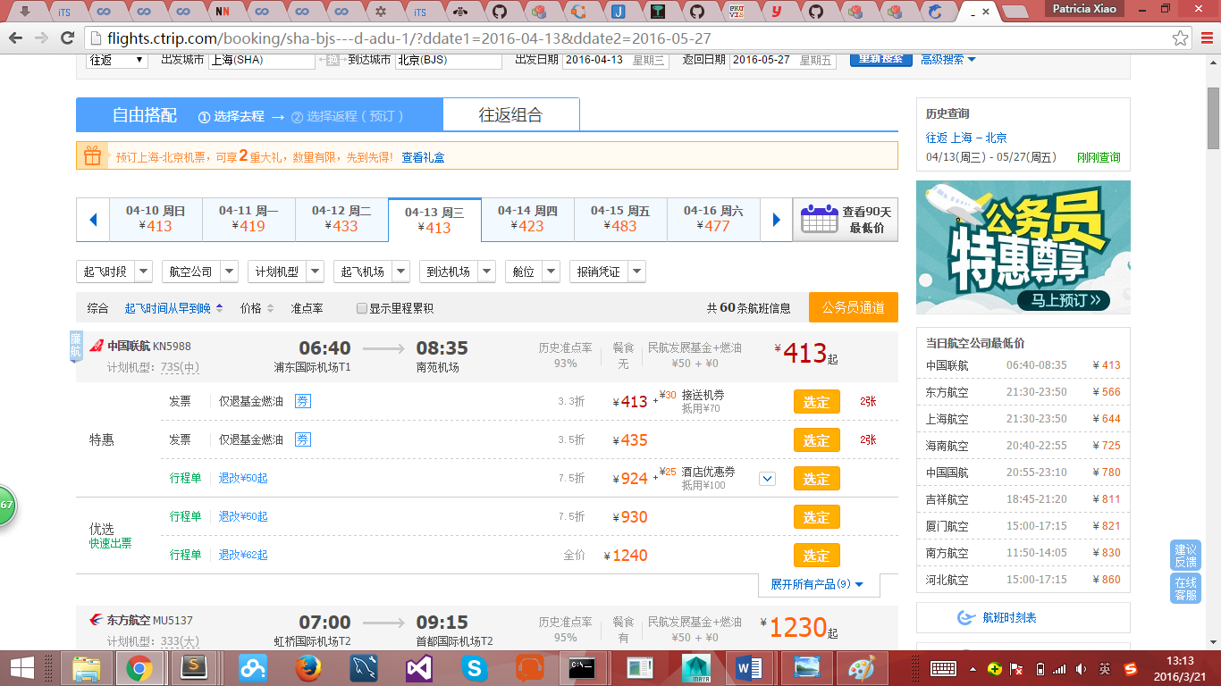

1. The platform weigh too much on prices. As you can see, even if you select to arrange them in the order of “起飞时间” (time of departure), within each time period the possible choices are arranged by the increasing order of prices. And on the right side there is a list showing the cheapest prices of the day. However, I find it a useless design (at least for me), for if I want to know about the price I would check for both the highest and the cheapest but it is only part of my consideration.

It could be easily observed from the pages that the platform has a principle in mind to provide the cheapest price possible. What make things worse is that there is no way to get rid of it. No personal options to change the view of the pages.

I would regard it as a vandalism of Freedom.

Severity Rating: 2

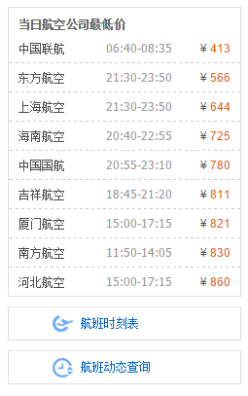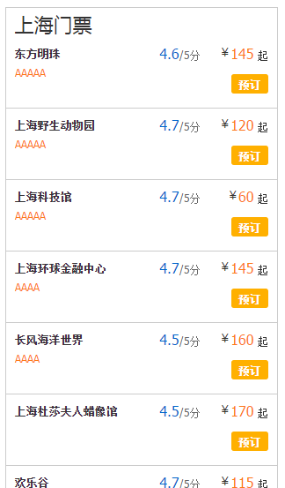

An interesting finding is that I find the bar above on the page of booking train tickets. It is the information about plane tickets on sale. This is an interesting design, I think it’ll be useful to attract more users to fly instead of travel by train.



1. There are some Consistency problems of the interface. The interface of the booking page of different kinds of tickets are way too different.

And even their interaction logics varied.

I understand that the official websites provides different interfaces for plane tickets, train tickets, bus tickets, etc. However, I believe that as a platform that aiming at combining different platforms together, it is its duty to make the pages look united.

Personally, I would suggest borrowing the layout from the train-ticket page, and the improved version of result-sorting from the airplane-ticket page.

Severity Rating: 3

Plane ticket:



Train ticket:

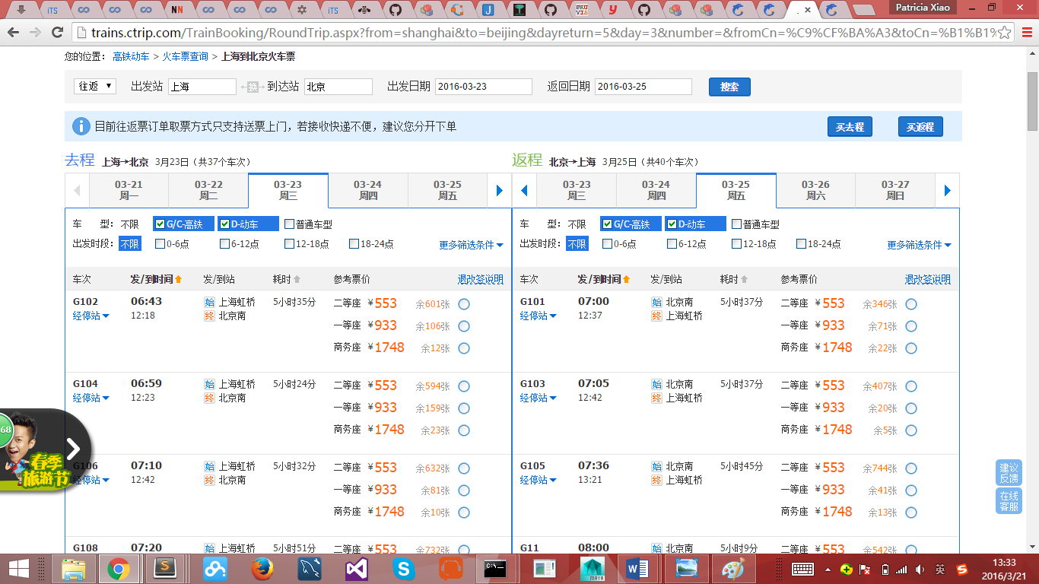

Bus ticket:

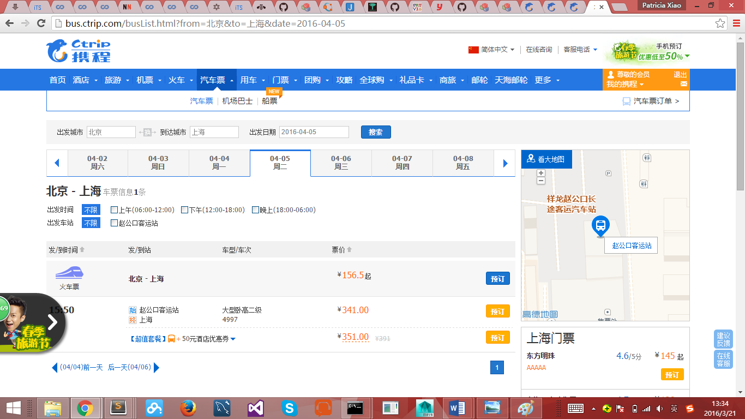

1. Perhaps the greatest problem is Visibility problem. Not long ago there are users reporting that the Ctrip platform is “cheating” on passengers by telling users they have gotten the tickets while they actually haven’t. The whole story is kind of complex to tell, in brief, the company would do something such as waiting for cheaper tickets or waiting for others to quit and then ask them to pay a lot to the company to save money, and increase their income.

Unfortunately I am unable to get a screen shot of my own, for this is a problem that only exist after the payment. If you understand Chinese, you are welcomed to look for more details on the website such as: <http://www.aiweibang.com/yuedu/80436219.html>. The following picture is picked from there.

The reason why I said that this problem has something to do with visibility is that, it is impossible for the users to check if the “ticket” is really valid on Ctrip. Ctrip would provide you with a false E-ticket number. We could choose to double-check it by visiting the official website of the air companies. But if we have to do so, what’s the point in using a platform which is said to provide us with convenience, such as Ctrip?

Severity Rating: 4

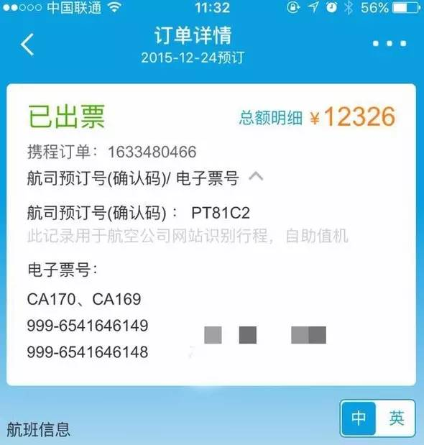

One funny thing is that it is said that there were someone who booked a ticket and got the E-ticket number 000-0000000000.

1. It harms the principle of Flexibility. The process is not simple enough. The following two pages have little difference, but users would have to jump between them to book an plane ticket.

Severity Rating: 3

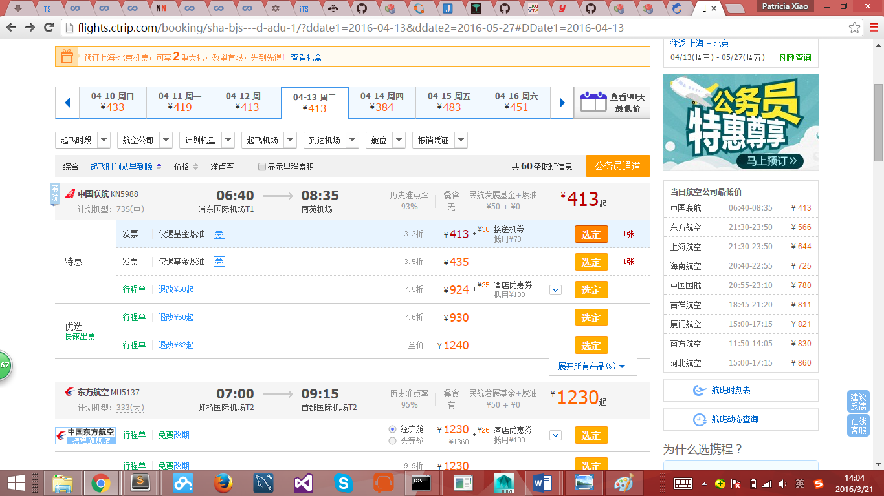

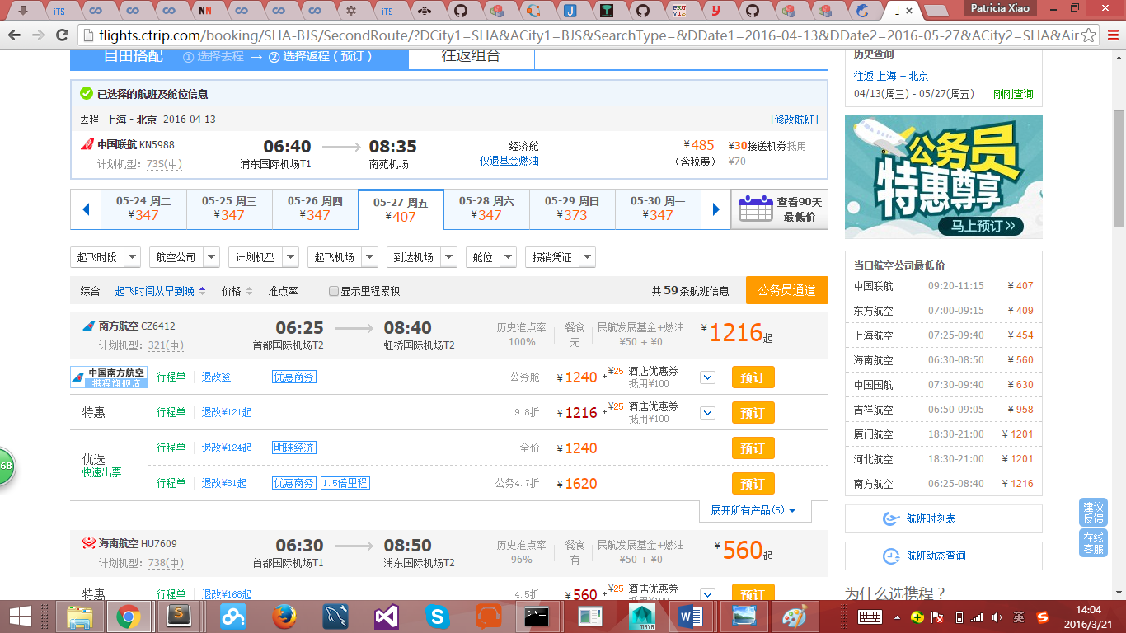

1. It harms your Freedom by forcing you to buy combos. You have no other choices, except that you go to the official website of the air companies instead.

Severity Rating: 4

